ROUND-1

Multiplication table

C

#include <stdio.h>

int main()

{

int i, j, n;

printf("Enter number for multiplication table: ");

scanf("%d", &n);

for (i = 1; i <= 10; i++)

{

printf("%d x %d = %d\n", n, i, n \* i);

}

return 0;

}

C++

#include <iostream>

using namespace std;

int main()

{

int i, j, n;

cout << "Enter number for multiplication table: ";

cin >> n;

for (i = 1; i <= 10; i++)

{

cout << n << " x " << i << " = " << n \* i << endl;

}

return 0;

}

Java

import java.util.Scanner;

public class Main {

public static void main(String[] args) {

Scanner sc = new Scanner(System.in);

int n;

System.out.print("Enter number for multiplication table: ");

n = sc.nextInt();

for (int i = 1; i <= 10; i++)

{

System.out.println(n + " x " + i + " = " + n \* i);

}

}

}

Python

n = int(input("Enter number for multiplication table: "))

for i in range(1, 11):

print(n, "x", i, "=", n\*i)

ROUND-2

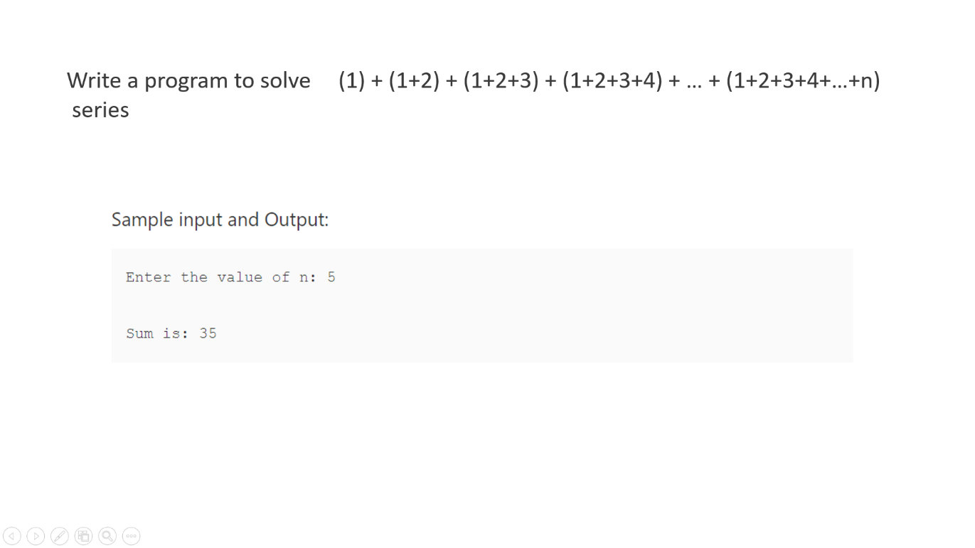

python

sum = 0

n = int (input("Enter the value of n:"))

for i in range(1,n+1):

for j in range(1, i+1):

sum = sum + j

print ("Sum is: ", sum)

c

#include <stdio.h>

int main()

{

int i, j, n, sum=0;

printf("Enter the value of n:");

scanf("%d", &n);

for(i=1; i<=n; i++)

{

for (j=0; j<=i; j++)

{

sum = sum + j;

}

}

printf("Sum is: %d", sum);

return 0;

}

C++(cpp)

#include <iostream>

using namespace std;

int main()

{

int i, j, n, sum=0;

cout << "Enter the value of n:";

cin >> n;

for(i=1;i<=n;i++)

{

for (j=0; j<=i; j++)

{

sum = sum + j;

}

}

cout << "Sum is: " << sum;

return 0;

}

Java

import java.util.Scanner;

class Series3

{

private static Scanner scan;

public static void main(String[] args)

{

int i, j, n, sum = 0;

scan = new Scanner(System.in);

System.out.println("Enter the value of n:\n");

n = scan.nextInt();

for(i=1;i<=n;i++)

{

for (j = 1; j <= i; j++)

{

sum = sum + j;

}

}

System.out.print("Sum: " + sum);

}

}

ROUND-3

C

#include<stdio.h>

int main()

{

int i, j, rows;

printf("Enter number of rows: ");

scanf("%d", &rows);

for(i=1; i<=rows; i++)

{

for(j=1; j<=rows-i; j++)

{

printf(" ");

}

for(j=1; j<=2\*i-1; j++)

{

printf("\*");

}

printf("\n");

}

return 0;

}

C++

#include <iostream>

using namespace std;

int main()

{

int i, j, rows;

cout << "Enter number of rows: ";

cin >> rows;

for(i=1; i<=rows; i++)

{

for(j=1; j<=rows-i; j++)

{

cout << " ";

}

for(j=1; j<=2\*i-1; j++)

{

cout << "\*";

}

cout << endl;

}

return 0;

}

Java

import java.util.Scanner;

public class Main {

public static void main(String[] args) {

Scanner sc = new Scanner(System.in);

int rows;

System.out.print("Enter number of rows: ");

rows = sc.nextInt();

for(int i=1; i<=rows; i++)

{

for(int j=1; j<=rows-i; j++)

{

System.out.print(" ");

}

for(int j=1; j<=2\*i-1; j++)

{

System.out.print("\*");

}

System.out.println();

}

}

}

Python

rows = int(input("Enter number of rows: "))

for i in range(1, rows+1):

for j in range(rows-i):

print(" ", end="")

for j in range(2\*i-1):

print("\*", end="")

print()